Community Lost & Found Matching Network
SRN: PES1UG25CS808
Problem Statement: #59
Primary Domain: Media, Events & Community
Target Actors: Finder / Owner, Community Admin
1. Problem Overview
The Community Lost & Found Matching Network is a community-based system designed to help users report lost and found items and identify potential matches.
The system extracts visual and text-based item tags and uses geo-proximity matching to compare lost and found items. When a potential owner claims an item, the system uses proof-of-ownership questions for verification before revealing contact details and allowing the handover process.
The main actors are the Finder / Owner and the Community Admin.
2. Functional Requirements
ID | Type | Description | Priority | Acceptance Criteria | Rationale
FR-001 | Functional | The system shall allow a Finder / Owner to create and submit a Lost Item or Found Item report containing item details, category, color information, location and relevant visual/text information. | High | Pass: Report is successfully stored with the required information. Fail: Report is submitted without required item information. | Provides the basic information required for identifying and matching lost and found items.
FR-002 | Functional | The system shall extract visual and text item tags from submitted item information and use these tags for identifying potential matches. | High | Pass: Relevant visual and text tags are extracted and associated with the item report. Fail: The system ignores available item tags during matching. | Item characteristics improve the identification of potentially matching lost and found items.
FR-003 | Functional | The system shall match newly logged Found Item posts with active Lost Item reports based on item category, color tags and location radius. | High | Pass: A compatible lost item within the specified matching criteria is identified and a potential match is generated. Fail: Incompatible item categories are matched. | Enables users to find potential matches efficiently.
FR-004 | Functional | The system shall allow a potential claimant to answer private proof-of-ownership questions before the claimant's contact details are revealed. | High | Pass: Correct answers allow the verification process to continue before contact details are revealed. Fail: Contact details are revealed without completing verification. | Helps prevent false claims and protects user contact information.
FR-005 | Functional | The system shall allow the Community Admin to review and manage lost and found reports and related claims. | Medium | Pass: The Community Admin can review and manage submitted reports or claims. Fail: The Admin cannot access or manage relevant reports. | Provides community-level administration and helps maintain reliable reports.

3. Non-Functional Requirements
ID | Type | Description | Priority | Acceptance Criteria | Rationale
NFR-001 | Performance & Security | Claim verification and matching operations shall provide acceptable response time while protecting private claimant information. | High | Pass: Benchmarking tests confirm the target latency and security standards under simulated peak load. Fail: The system exceeds the target latency or exposes protected claimant information. | The system must remain responsive while protecting sensitive user information.
NFR-002 | Security | Claimants must complete the private proof-of-ownership verification process before their contact details are revealed. | High | Pass: Contact details remain hidden until successful verification. Fail: Contact details are revealed before successful verification. | Prevents unauthorized claims and protects the privacy of Finder / Owner contact information.

4. Actors
Finder / Owner
The Finder / Owner is the primary community user who can report lost or found items, view potential matches and participate in the ownership verification process.
Community Admin
The Community Admin manages community reports and claims and helps maintain the reliability of the lost-and-found network.
5. Primary Use Cases
The major use cases are:
- Register / Login
- Report Lost Item
- Report Found Item
- Extract Item Tags
- Find Potential Matches
- View Match
- Submit Ownership Claim
- Verify Ownership
- Reveal Contact Details
- Manage Reports
- Manage Claims
6. Use-Case Diagram
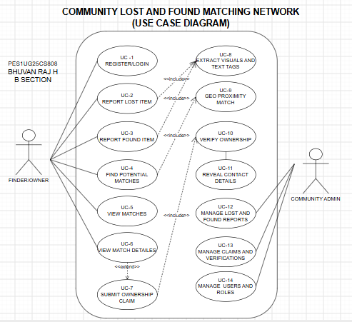
7. Use-Case Flow Specification
Use Case: Find Potential Match for a Lost/Found Item
Primary Actor: Finder / Owner
Preconditions
- The Finder / Owner has access to the system.
- A Lost Item or Found Item report has been submitted.
- The report contains sufficient item information for matching.
- Active lost or found reports are available for comparison.
Postconditions
- The system identifies compatible potential matches.
- The potential match is displayed to the Finder / Owner.
- The Finder / Owner can proceed with an ownership claim if the displayed item appears to be theirs.
Main Success Scenario
- The Finder / Owner submits a Lost Item or Found Item report.
- The system stores the submitted item information.
- The system extracts visual and text item tags.
- The system identifies active reports of the opposite type.
- The system compares the item category and color tags.
- The system performs geo-proximity matching using the reported location.
- The system identifies compatible reports.
- The system calculates or identifies a potential match.
- The potential match is presented to the Finder / Owner.
- The Finder / Owner can select the potential match and submit an ownership claim.
- The system proceeds to proof-of-ownership verification before revealing contact details.
Alternate Flow
A1 — No Compatible Match Found
- The system compares the submitted report with available active reports.
- No report satisfies the required matching criteria.
- The system does not generate an incompatible match.
- The Finder / Owner is informed that no suitable match is currently available.
- The report remains available for future matching when new Lost or Found Item reports are submitted.
8. Security Consideration
The ownership verification process is an important part of the system. A claimant must answer private security/proof-of-ownership questions before contact details are revealed. This requirement is directly specified in the supplied problem statement.
9. Conclusion
The Community Lost & Found Matching Network provides a structured way for community members to report lost and found items and identify potential matches. The system uses visual and text item tags together with geo-proximity matching. Proof-of-ownership verification helps ensure that contact details are protected and that claims are handled securely.

